**DAILY ONLINE ACTIVITIES SUMMARY**

|  |  |  |  |  |  |  |  |  |
| --- | --- | --- | --- | --- | --- | --- | --- | --- |
| **Date:** | **23/06/2020** | | | | | **Name:** | **Spoorthi M S** | |
| **Sem & Sec** | **6th /B** | | | | | **USN:** | **4AL17CS097** | |
| **Online Test Summary** | | | | | | | | |
| **Subject** | | **PAP(assignment 4)** | | | | | | |
| **Max. Marks** | | **20** | | **Score** | | | **18** | |
| **Pre-Placement Training Summary** | | | | | | | | |
| **Pre placement training** | **9:00 am to 11:00 am - Programming in Java**  **11:00 am to 1:00pm - Datastructures** | | | | | | | |
| **Faculty** | | | **Mr.Sharan Pias**  **Mrs.Merlyn Melita** | | **Duration** | | | **4 hr** |
| **Assessments** | | | | | | | | |
| Java Quiz in techgig. | | | | | | | | |
| **Status: Completed** | | | | | | | | |
| **Uploaded the report in Github** | | | | | **Yes** | | | |
| **If yes Repository name** | | | | | <https://github.com/msspooorthi/pre-placement-training> | | | |
| **Uploaded the report in slack** | | | | | **Yes** | | | |

**Online Test:**

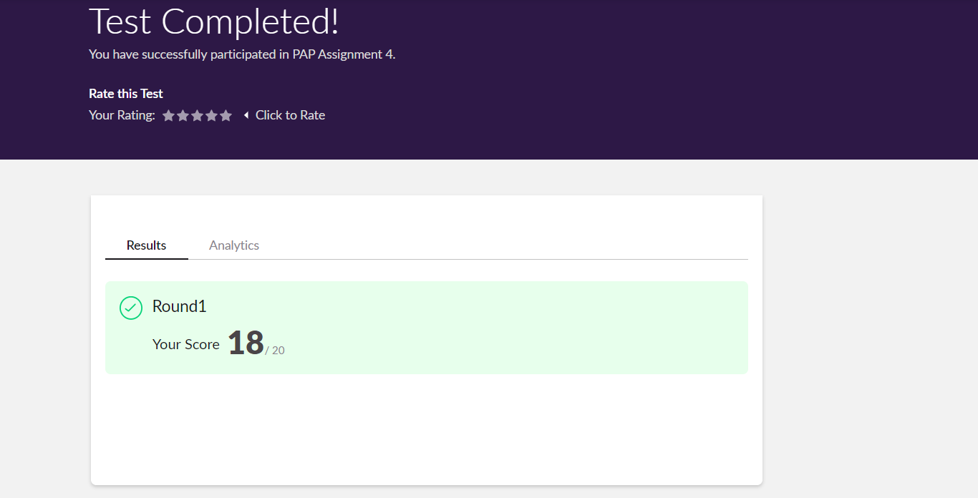

**Training snapshots:**

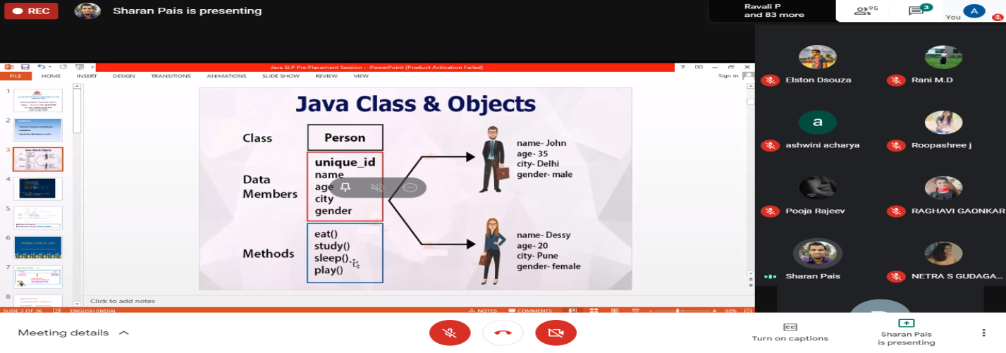

**Assessments:**

